Start with Begin branch

Make sure Docker for Windows is set for Linux

Modify solution to start both Web APP and Web API project with Web API first

Right click on Web APP project add -> Container Orchestration Support

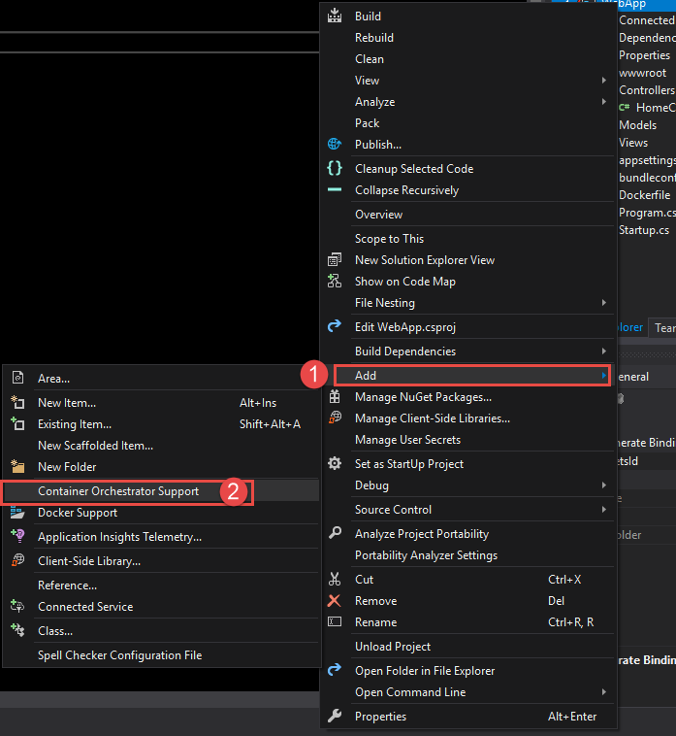

Choose Docker Compose then Linux OS

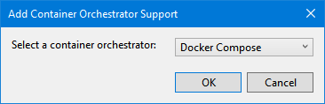

Review Dockerfile and docker-compose

Right click on Web API Project and add docker-compose

the Compose file is almost done but we need to add

1. Dependencies
2. Environment Variables

services:

webapp:

image: ${DOCKER_REGISTRY}/webapp

build:

context: .

dockerfile: WebApp/Dockerfile

depends_on:

- webapi

environment:

ApiHost: "webapi"

webapi:

image: ${DOCKER_REGISTRY}/webapi

build:

context: .

dockerfile: WebAPI/Dockerfile

go to PowerShell prompt in the Solution Directory (contains docker-compose.yml)

**docker-compose up -d**

show app and that the hostnames match the container names

Scale Application

**docker-compose scale webapi=3**

show app where the API layer is changing to different containers

Shut down the app

**docker-compose down**

**must be in same directory as compose file